Rice and Wheat Production Growth in India post Green Revolution

Raghav Goyal1, Nonit Mittal2, Kavita Choudhary*3, Umesh Gupta4

1,2Student, JK Lakshmipat University

3,4Associate Professor, JK Lakshmipat University, Jaipur, Rajasthan

[1raghavgoyal@jklu.edu.in](mailto:1raghavgoyal@jklu.edu.in) , [2nonitmittal@jklu.edu.in](mailto:2nonitmittal@jklu.edu.in) ,

[3kavitachoudhary@jklu.edu.in](mailto:3kavitachoudhary@jklu.edu.in) , [4umeshgupta@jklu.edu.in](mailto:4umeshgupta@jklu.edu.in)

**ABSTRACT**

India tops rice, pulses, wheat and spices in the world production table. Although the third major sector contributing to the Indian economy is agriculture (and other related sectors), it accounts for only about 17 percent of GDP but provides about 60 percent of the total number of jobs available in India. India has distinct advantages of providing the country-wide cultivation of varied crops with the highest arable land area (60.44 percent) of 179.8 million hectares and varied agro-based climatic conditions. India 's agricultural (primary) sector has a crucial role to play in politics, economics and society. In the Global South, an enormous technology transition took place in the 1960s that succeeded in increased agricultural production. The transition from centuries-old methods of cultivation to mechanisation has not only changed the productivity of horticulture, but also the lives of millions of people and the community.

In this paper, the authors examined the shift in the production of wheat and rice in India in the decades following the green revolution, analysed the production and export of wheat and rice after 1987, and observed whether these two factors are still influenced by the green revolution of 1965. The paper also concentrates on the scale of the green movement in various states. After analysing rice and wheat food grain production data (from 1950 to 2005), food grain production in India increased in output after 1965 (India was introduced by the Green Revolution). It has been a remarkable rise. As production is growing, exports are also increasing. India is second largest wheat producing country. There is a direct relationship between exports and production. At the moment of the green revolution, the technical advances introduced still impact overall output and rise linearly over time. But in India, there are many states that still lack certain technologies to increase yield.

***Keywords: GDP, Agriculture, Agro-Climatic conditions, Economics, Computational Statistics***

**INTRODUCTION**

**GREEN REVOLUTION IN INDIA**

In the 1960s an immense technology transfer occurred in the Global South that resulted in increased agricultural production. The switch from centuries old cultivation methods to mechanization resulted in not only affecting the horticultural productivity but also the lives of millions of people and the environment.

Before and during the struggle for independence, agriculture sector was the driving engine for Indian economy. Still the situation of agricultural sector was pitiful. From low production per acre, dearth of investment, insufficiency of technology, and more such problems afflicted the industry. Therefore, government of India came into action to introduced farmers with HYV seeds which lead to the Green Revolution.

|  |  |
| --- | --- |
| **Rise in Agricultural Production** | Raised from just 11 MT in 1960 to 55 MT in 1990 |
| **Rise in per Acre Yield** | Raised from 850 kg/hectare to 2281 kg/hectare by 1990. |
| **Decreased Dependence on Imports** | Import of food grains decreased very fast. Production was not just enough for population, but we were able to store surplus for emergencies. |
| **Employment** | India saw an increase in rural employment by creation of new jobs for the workforce in Irrigation, transportation, food processing and marketing services |
| **Advantage to the Farmers** | Farmers were now exercising commercial farming in place of sustenance farming. Due to this income of farmers increased which means better living conditions and affordability of quality facilities. |

**Table1: *Effects of the Green Revolution***

**METHODOLOGY**

SECONDARY STATISTICAL ANALYSIS

Secondary Statistical Analysis is a quantitative, systematic research method and an analytical tool to examine the secondary data, the already existing data which have been collected by other researchers, institutions or national governments. Secondary Analysis is an empirical practice which applies similar research principles as primary data utilizing studies. The tool provides us a larger analytical space because we can collect, use and apply the data for purposes other than it was originally intended for. The method is cost and time effective since we did not have to spend money or time to get access to or collect the datasets.

**CORRELATION**

Correlation is a statistical measure which is used to analyse how two different variables are dependent on each other by how much extent. This statistical tool analyses the relationships between two individual variables.

The following formula is for calculating Correlation coefficient ‘r’:

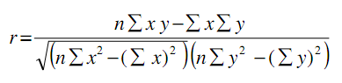

where, x and y are values of variables and n is size of the sample.

Strength of linear relation is described by the magnitude of ‘r’ and direction indicated by its sign.

If the value of ‘r’ is near to +1 or -1 then it shows a strong positive or negative linear relation respectively.

Else if the value of ‘r’ is close to 0, this implies weak or no linear association.

**REGRESSION**

Linear regression is a statistical method used in various sectors like finance, investing, etc., for determining the strength of linear relationship between one dependent variable and a series of independent variables. In simple linear regression, one independent variable is used to predict or explain the dependent variable and used to find the linear approach to modelling the mathematical relationship between them. It is assumed that the variables are linearly related to each other.

The equation of simple linear regression line can be written as:

$$h\left(x_{i}\right)=β_{0}+β_{1}x_{i}$$

where,

h(xi) is equal to the predicted response value (dependent variable)

b0 indicated y-intercept of the line

b1 represents slope of regression line.

where,

$β_{1}=\frac{{SS}_{xy}}{{SS}_{xx}}$ $β_{0}=\overline{y}-β_{1}\overline{x}$

where

SSxy = sum of cross-deviations of y and x: ${SS}_{xy}=\sum_{i=1}^{n}{\left(x_{i}-\overline{x}\right)\left(y_{i}-\overline{y}\right)}=\sum_{i=1}^{n}{{x_{i}}^{2}-n\overline{x}\overline{y}}$

SSxx = sum of squared deviations of x: ${SS}_{xy}=\sum_{i=1}^{n}{{\left(x_{i}-\overline{x}\right)}^{2}}=\sum_{i=1}^{n}{{x_{i}}^{2}-n{\left(\overline{x}\right)}^{2}}$

**TIME SERIES ANALYSIS**

Time series analysis is a statistical approach for analysing and finding out meaningful statistical inferences from time series/dependent data. Time series data means that the data is in a series of time periods or intervals. It can also be used to study and analyse how the changes are related with the chosen data point is compared to shifts in the other variables over the same period of time. Time series forecasting is a model which is used to predict future values based on previously observed values.

**EXPONENTIAL SMOOTHING**

Exponential smoothing is a method used to predicts the one value of next period based on the past and the current values.  It is performed by doing the averaging of data such that the non-systematic components of each individual observation cancel out each other. Due to unreliability of predicted long-term forecasts using this technique, this method is better used to predict short term forecasts.

The formula is: **St = αyt-1 + (1-α) St-1**

Where, α = the smoothing constant (0 - 1)

t = time period

St = smoothed value of time period t

**RESULTS AND DISCUSSIONS**

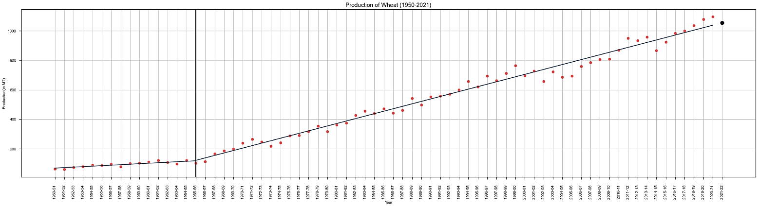

**Figure1: *Production of Wheat against Years (1950-2021*)**

Graph obtained shows that, technological advancements of **Green Revolution (1965)** boosted the wheat production significantly and it is still increasing.

Using *Time Series Analysis Techniques,*

**Estimated Production of Wheat in 2021-2022 is *1054.23 (in Million Tons)***

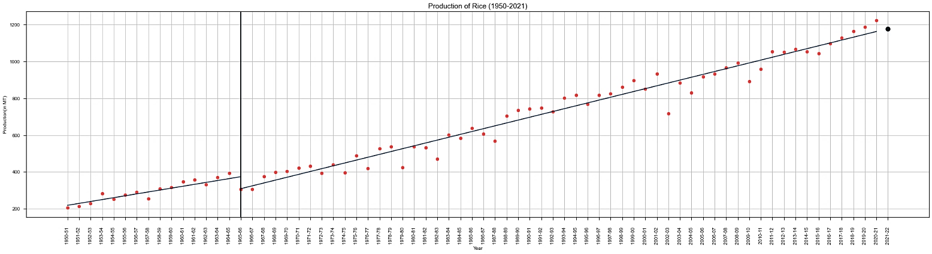

**Figure2: *Production of Rice against Years (1950-2021)***

This graph when plotted between *Production of Rice and Years (1950-2020)*isgiving out same results.

Using *Time Series Analysis Techniques,*

**Estimated Production of Rice in 2021-2022 is *1178.69 (in Million Tons)***

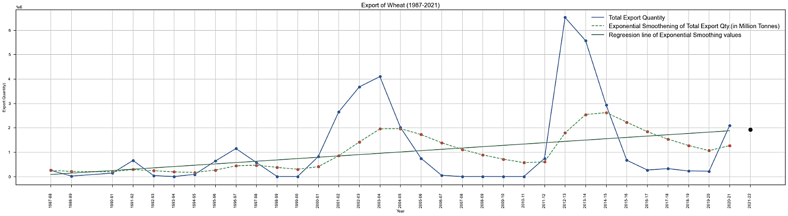

**Figure3: *Estimated Export of Wheat for Year 2021-22***

After 1987 (two decades post green revolution), India was able produce sufficient yield to meet its wheat and rice consumptions and reached to a level that India is now second largest producer of wheat and rice.

Export of surplus produce started and is increasing every year.

**Estimated Export of Wheat in 2021-2022 is *1927437.37 (in Metric Tons)***

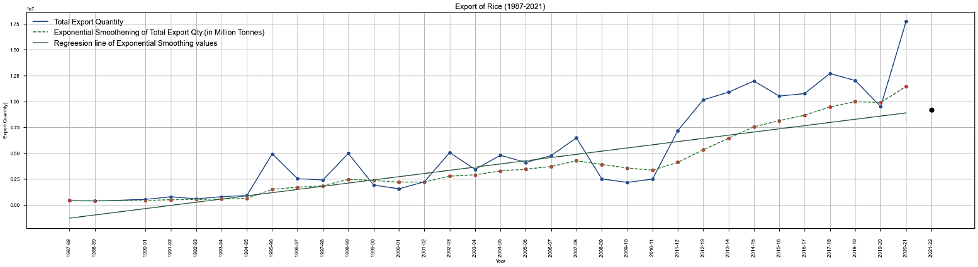

**Figure4*: Estimated Export of Rice for Year 2021-22***

**Estimated Export of Rice in 2021-2022 is *9194513.49 (in Metric Tons)***

After analysing statewise production of wheat in India (after 1990 in gaps of five years), estimated production in 2020-22 is given in the table below.

It can be observed that UP, Punjab, Haryana and MP are the top wheat producing states in India with overall increasing production.

|  |  |  |  |  |  |  |  |
| --- | --- | --- | --- | --- | --- | --- | --- |
| **States** | **Wheat** | | | | | |  |
|  | **1990-95** | **1995-00** | **2000-05** | **2005-10** | **2010-15** | **2015-20** | **2020-22** |
| **(Predicted)** |
| ALL INDIA | 293641.8 | 345453.9 | 349001 | 385214.4 | 457639 | 501550.1 | 204658.08 |
| Uttar Pradesh | 102046.4 | 118145.7 | 122359.3 | 130855.8 | 142903.8 | 153917.1 | 65909.02 |
| Punjab | 63738 | 69275 | 74412 | 75711 | 83013.1 | 86225.3 | 34343.02 |
| Haryana | 34559 | 40889 | 46466 | 50456.2 | 57586.7 | 14024.2 | 6574.69 |
| Madhya Pradesh | 30258.4 | 38698.6 | 30335 | 34248 | 62339.9 | 900.6 | 510.77 |
| Rajasthan | 23007 | 32588 | 28396.5 | 34833.9 | 44296.7 | 49223.8 | 20311.55 |
| Bihar | 19235.9 | 22739.1 | 19822 | 20581.6 | 22922.8 | 27996.8 | 11292.3 |
| Gujarat | 6600.2 | 6829.1 | 6492.3 | 14256 | 18788.5 | 339.1 | 69.12 |
| Maharashtra | 4509.1 | 5480.3 | 4803 | 8265.8 | 7705 | 87667.3 | 30786.7 |
| West Bengal | 3051.6 | 4003.7 | 4734.7 | 4101.9 | 4510.3 | 3056.3 | 1464.56 |
| Himachal Pradesh | 2802.9 | 2934.1 | 2566 | 2559.4 | 3068.1 | 58114.5 | 24409.87 |
| Jammu and Kashmir | 1653.9 | 2011 | 1827.5 | 2205.6 | 2325.2 | 3065.5 | 1206.67 |
| Karnataka | 788.8 | 891.4 | 865.7 | 1181 | 1122 | 1923.2 | 848.15 |
| NCT of Delhi | 537.5 | 214.9 | 442.5 | 400.4 | 431.4 | 24.8 | 7.39 |
| Assam | 499.1 | 510.8 | 390.1 | 309.8 | 226.5 | 120.6 | 54.34 |
| Odisha | 131.3 | 31.4 | 41.8 | 32.2 | 10.4 | 1.3 | -8.14 |
| Sikkim | 76.9 | 63.3 | 45.2 | 36.2 | 6.8 | 1.1 | -0.35 |
| Andhra Pradesh | 37.7 | 37.8 | 43 | 52 | 38 | 0 | 5.69 |
| Arunachal Pradesh | 36 | 28.6 | 32.8 | 27.7 | 28.8 | 30.8 | 5.64 |
| Tripura | 33.4 | 18 | 14.4 | 9.1 | 3 | 1.6 | -0.43 |
| Meghalaya | 307 | 32.5 | 19.5 | 4.9 | 3.6 | 7595.8 | 3984.51 |
| Nagaland | 4.8 | 28.9. | 75 | 9.3 | 27.7 | 3.6 | -0.01 |
| Chhattisgarh | 0 | 0 | 472.6 | 495.6 | 670.5 | 706.6 | 404.97 |
| Jharkhand | 0 | 0 | 591 | 673.6 | 1481.3 | 2176.3 | 473.24 |
| Uttarakhand | 0 | 0 | 3747.4 | 3902 | 4110.8 | 4425.5 | 1988.21 |

**Table2: *State wise Wheat Production in India and prediction for year 2020-22***

In case of rice, West Bengal, Uttar Pradesh, Andra Pradesh and Punjab are the leading rice producing states in India with overall increasing production.

|  |  |  |  |  |  |  |  |
| --- | --- | --- | --- | --- | --- | --- | --- |
| **States** | **Rice** | | | | | |  |
| **1990-95** | **1995-00** | **2000-05** | **2005-10** | **2010-15** | **2015-20** | **2020-22** |
|  | **(Predicted)** |
| ALL INDIA | 383948.9 | 416015.7 | 421794.5 | 470117 | 518640 | 561488.5 | 226982.56 |
| West Bengal | 58182.9 | 64816.6 | 71621.1 | 73354.2 | 72723.3 | 78035.3 | 32654.04 |
| Uttar Pradesh | 49956.1 | 58923.2 | 56704.5 | 57941.8 | 67233.9 | 70592.1 | 29277.54 |
| Andhra Pradesh | 46534.3 | 50726 | 49728.8 | 61679 | 43230.2 | 40000.9 | 17427.3 |
| Punjab | 35637 | 38662 | 46943 | 53056 | 55127 | 61391.9 | 24413 |
| Tamil Nadu | 33497 | 29761 | 25812.4 | 27718.7 | 28378.6 | 29827.4 | 12816.68 |
| Odisha | 30292.2 | 27447.7 | 28238.4 | 34954.6 | 35841.8 | 36846.7 | 16095.65 |
| Madhya Pradesh | 28695.6 | 27743.5 | 6625.9 | 7306.9 | 13244.5 | 21170.2 | 6212.14 |
| Bihar | 27364.3 | 31118.4 | 23651 | 22092.5 | 29656.5 | 35588.1 | 12552.46 |
| Chhattisgarh | 26338.53 | 26338.53 | 20913.206 | 24254.7 | 29623 | 32070.3 | 12803.57 |
| Assam | 16437.3 | 17216.9 | 18941.2 | 18131.9 | 24531.2 | 25341.4 | 10053.13 |
| Karnataka | 14660.4 | 16821.8 | 15568.1 | 20400 | 18620.6 | 15708.4 | 7866.33 |
| Jharkhand | 12657.55 | 12657.55 | 9688.91 | 12959.4 | 11754.5 | 16708.7 | 5714.25 |
| Maharashtra | 11659.2 | 12618.3 | 11433.6 | 12727 | 14660 | 14606.6 | 6309.49 |
| Haryana | 9799 | 11874 | 13702 | 17117 | 19211 | 22461.8 | 8693.79 |
| Kerala | 5210.8 | 3423.27 | 3380.7 | 2978 | 2671.3 | 2691.6 | 1081.21 |
| Gujarat | 4092 | 4815.6 | 4569.7 | 6757 | 8294.5 | 9418.1 | 3896.68 |
| Uttarakhand | 2951.4 | 2951.4 | 2878.18 | 2893 | 2910.8 | 3191.8 | 1312.77 |
| Jammu and Kashmir | 2705.7 | 2469.4 | 2254.1 | 2732.6 | 2998.6 | 2347.5 | 522.49 |
| Tripura | 2321 | 2264.5 | 2764.8 | 3065.1 | 3592.8 | 3214.7 | 689.68 |
| Manipur | 1711.1 | 1798 | 1918.7 | 1895.3 | 2102.9 | 1778.6 | 410.42 |
| Nagaland | 836.2 | 867.3 | 1200.1 | 1402.6 | 2052.8 | 1361.8 | 354.98 |
| Rajasthan | 752.7 | 940.2 | 718.8 | 1051.8 | 1420.7 | 2207.1 | 968.9 |
| Goa | 682.6 | 783.7 | 719.3 | 623.1 | 606.6 | 430.1 | 112 |
| Arunachal Pradesh | 652.3 | 632.3 | 709.4 | 830.2 | 1313.2 | 897.3 | 212.79 |
| Meghalaya | 584.2 | 723.4 | 953.3 | 962.7 | 1227.6 | 1010.7 | 239.34 |
| Himachal Pradesh | 533.9 | 578.4 | 590.6 | 581.3 | 631.8 | 650 | 274.31 |
| Mizoram | 415.7 | 520.6 | 537.3 | 234.7 | 251.7 | 243.2 | 54.27 |
| Puducherry | 314.6 | 287.5 | 320.6 | 276.4 | 243.1 | 201.9 | 47.11 |
| Sikkim | 109.7 | 110.8 | 107.7 | 111.9 | 103.6 | 67.6 | 17.95 |
| NCT of Delhi | 20.1 | 34.1 | 67.8 | 137.2 | 114.6 | 68.2 | 23.65 |

**Table3: *State wise Rice Production in India and prediction for year 2020-22***

**CONCLUSION**

In India, Green Revolution has helped in achieving self-sufficiency in food production. Trade of surplus yield has contributed to India’s Economy as well. This revolution has led to many other socioeconomic benefits.

Production of food grains in India is strongly correlated to the population. It is not correlated with area of production and rainfall, which means the increasing yield is because of technological advancements that took place decades back and spread wide across the country.

**FUTURE SCOPE**

Green revolution was introduced for wheat and rice (major food grains) in India. Did technological advancements and changes in this revolution transferred to Horticulture Crops and led to NHM (National Horticulture Mission)? Was Golden Revolution as impactful as Green Revolution?

**REFERENCES**

1. <https://www.rbi.org.in/Scripts/AnnualPublications.aspx?head=Handbook%20of%20Statistics%20on%20Indian%20Economy>
2. Madhusudhan L (2015) Agriculture Role on Indian Economy. Bus Eco J 6:176. doi:10.4172/2151-6219.1000176
3. https://www.export.gov/article?id=India-Agricultural-Sector
4. Asada, Haruhisa, and Jun Matsumoto. "Effects of rainfall variation on rice production in the Ganges-Brahmaputra Basin." Climate Research 38, no. 3 (2009): 249-260.
5. Auffhammer, Maximilian, Veerabhadran Ramanathan, and Jeffrey R. Vincent. "Climate change, the monsoon, and rice yield in India." Climatic change 111, no. 2 (2012): 411-424.
6. CHAKRAVARTI, ARAVINDA K. "Green revolution in India." Annals of the Association of American Geographers 63, no. 3 (1973): 319-330.
7. Dev, S. Mahendra, and Alakh N. Sharma. "Food security in India: Performance, challenges and policies." (2010).
8. Hira, G. S. "Water management in northern states and the food security of India." Journal of Crop Improvement 23, no. 2 (2009): 136-157. 9. https://www.omicsonline.org/open-access/agriculture-role-on-indian-economy-2151-6219-1000176.php?aid=62176
9. Joshi, A. K., B. Mishra, R. Chatrath, G. Ortiz Ferrara, and Ravi P. Singh. "Wheat improvement in India:
10. Krishna Kumar, K., K. Rupa Kumar, R. G. Ashrit, N. R. Deshpande, and James William Hansen. "Climate impacts on Indian agriculture." International Journal of Climatology: A Journal of the Royal Meteorological Society 24, no. 11 (2004): 1375-1393.
11. Pinstrup‐Andersen, Per, and Peter BR Hazell. "The impact of the Green Revolution and prospects for the future." Food Reviews International 1, no. 1 (1985): 1-25.
12. Saxena, Nareesh C. "Hunger, under-nutrition and food security in India." In Poverty, Chronic Poverty and Poverty Dynamics, pp. 55-92. Springer, Singapore, 2018.
13. Time Series Analysis - Statistics Solutions. (2020). Retrieved 19 October 2020, from https://www.statisticssolutions.com/time-series-analysis/
14. Yadav, Rajbir, S. S. Singh, Neelu Jain, G. P. Singh, and K. V. Prabhu. "Wheat production in India: Technologies to face future challenges." Journal of Agricultural Science 2, no. 2 (2010): 164.